BEGINS:
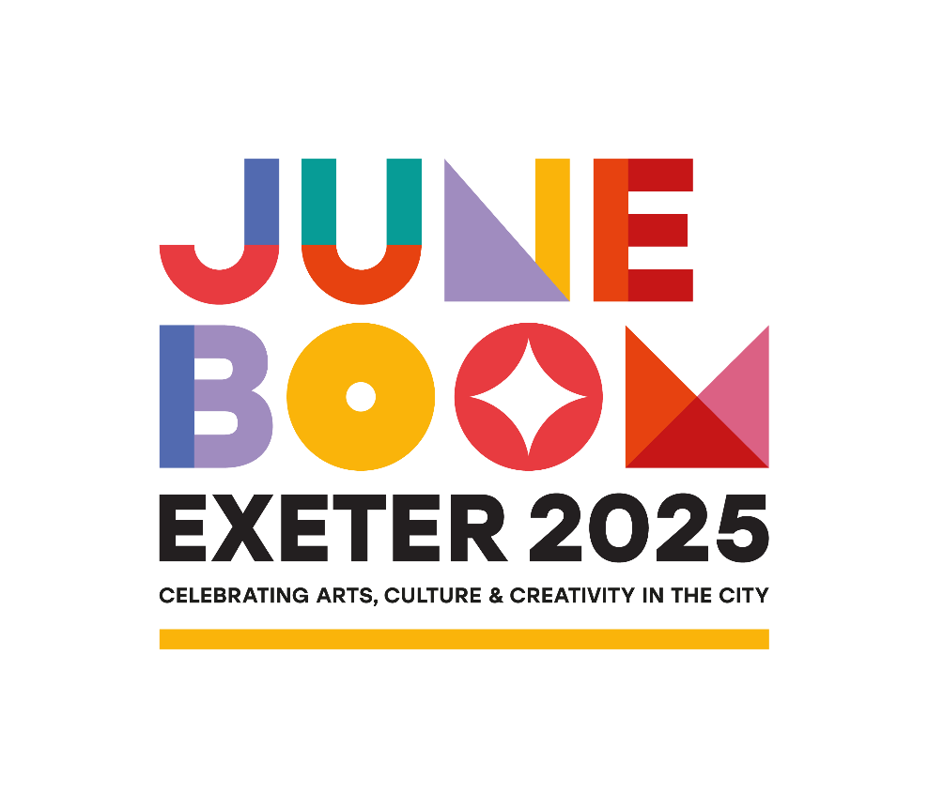
Get Ready for June Boom: Exeter’s Month of Culture, Comedy, Music and More!
Exeter is set for an unforgettable June as the city comes alive with June Boom — a month-long celebration packed with vibrant events, arts, culture, and entertainment.
From live music and laugh-out-loud comedy to inspiring heritage festivals and creative arts and literature events, there’s something for everyone — and you won’t want to miss a thing.
Nicola Wheeler, CEO at InExeter, says:
"Exeter is already an amazing place to visit, but this June, it’s going to be buzzing! We’re shouting from the rooftops, so no one misses out. From live music and comedy to vibrant community festivals, Exeter has it all. We encourage everyone to explore and discover all the exciting events happening this June in the city!”
Bumper Weekend: 7–8 June
Mark your calendars for the Bumper Weekend, kicking off with the much-loved Exeter Respect Festival — the city’s longest-running celebration of diversity and multiculturalism. Taking over Belmont Park with the theme “Peace and Harmony Between Communities”, this vibrant event typically welcomes around 20,000 visitors and features international reggae star Da Fuchaman, the Soul of the City Gospel Choir, plus an exciting mix of music, dance, street food, and community activities.
Dr. Suaad Genem, Exeter Respect Festival, says:
"Exeter Respect Festival is unique. Its message of diversity, equality, and human rights has remained the same since 1997, and it’s the biggest celebration of its kind in the South West."
But that’s just the beginning! The city will be bustling with even more unmissable events:
- Exeter Comedy Festival (5–8 June): Big-name comedians, rising stars, live podcasts, workshops and family shows in fantastic independent venues.
Festival founder Will Adamsdale says:
“Exeter Comedy Festival is back—bigger than ever with over 60 shows across 15 unique venues. From intimate gigs in indie shops to big-name acts testing new material, it’s a celebration of comedy and community right in the heart of the city.”
- Heritage Harbour Festival on the Quay (8 June): Steamboats, classic cars, live music, and street entertainment by the water.
- Exeter UNESCO City of Literature Book Market: Taking over Cathedral Green on 8 June, the Book Market brings together local authors, independent publishers, and literary organisations for a day celebrating Exeter’s literary heritage and creativity. It’s the perfect chance to discover a new read, meet writers, and soak up the festival atmosphere in a stunning setting.
A Month Full of Highlights
And the excitement continues all month:
- Art Week Exeter (9–15 June): A city-wide festival packed with exhibitions, performances, and workshops across city centre venues. Top tip: Don’t miss the Art Car Boot taking place on 15 June at Piazza Terracina where artists, makers and crafters turn their car boots or trestle tables into pop up galleries packed with unique art treasures.
- Reclaim Festival (9–14 June): A vibrant week celebrating women's contributions to the arts, packed with performances, panel discussions and networking events.
- Magdalen Road Creative Street Festival (21 June): Happening in the ‘village street in the heart of the city’ this Street Festival will include live music, crafts, demonstrations, stalls, fresh local food and so much more.
- Brand New: Exeter Quayside Farmers' Market
A new addition to the city, the Exeter Quayside Farmers' Market will hold its grand opening on June 21 at Piazza Terracina. Enjoy a variety of locally sourced produce, artisanal goods, plants, and more.
Councillor Bob Foale, Lead Councillor for Arts, Culture and Tourism, Exeter City Council says:

“Exeter offers a huge variety of events throughout the year, and we are proud to highlight just some of these during June Boom. Whether you live in Exeter or are visiting our city, take a look at the programme as there is something for all ages and interests and you might discover something new.”
Exeter’s Venues: Always Delivering Excitement
Exeter’s top venues — Exeter Phoenix, Northcott Theatre, Corn Exchange, Exeter Cavern and more — will be bursting with performances, workshops, exhibitions, and special events throughout June. From Jimmy Tarbuck to Katherine Ryan, emerging musicians to tribute acts offering a taste of all time classics from the Beatles and Queen. For theatre lovers there is local Shakespeare performances to Pride and Prejudice* (*Sort Of) – an all-female adaptation of Jane Austen's classic love story to Theatretrain delivering Aladdin Junior.
Martin Berry, Creative Director of Exeter Northcott Theatre, captures the excitement for June Boom: “June Boom is a vibrant showcase of Exeter’s arts, culture, and creativity. It’s a brilliant opportunity to support talented artists, open up our venues to new audiences, and celebrate everything that makes the city’s cultural scene so special."
Don’t Miss June Boom!
This June, Exeter will be buzzing with creativity, culture, and community spirit. Plan your month and discover more at visitexeter.com/juneboom.

ENDS
Images to accompany: June Boom Image Gallery
Press Information:
For further information, please contact:
Alice Evans, Marketing and Communications Manager alice@inexeter.com
InExeter, 22b Waterbeer Street, Exeter, EX4 3EH
01392 424975
Notes to editors:
June Boom
June Boom is a coordinated campaign between InExeter, Exeter Culture and Visit Exeter to amplify all the amazing events happening in June in Exeter city centre, celebrating all the fantastic work by cultural producers and shining a spotlight on events venues within Exeter.
www.visitexeter.com/juneboom
InExeter
InExeter is the Business Improvement District for Exeter city centre.
Business Improvement Districts are business-led partnerships which are created through a ballot process to deliver additional services to local businesses for a period of 5 years.
InExeter has been supporting businesses in Exeter since 2015. Following a successful ballot in November 2024, InExeter secured a third term and will continue to support the city centre for a further 5 years from April 2025 – March 2030.
Run by business for business, InExeter celebrates the city and supports local business through a range of initiatives, schemes, and projects.
"Celebrating our City” is a strategic objective for InExeter and a key priority in the 2025-2030 business plan. InExeter is committed to promoting Exeter as a distinctive destination.
www.inexeter.com
Exeter Culture
Exeter Culture is an initiative that champions the growth, visibility, and vibrancy of culture across the city. Hosted by the University of Exeter through its Creative Industries and Economy team, it was originally established as a time-limited programme but continues to serve as a vital platform for cultural engagement, promotion, and collaboration. www.exeterculture.com

Visit Exeter
Visit Exeter is managed by Exeter City Council and is the official destination marketing organisation responsible for promoting Exeter as a destination for short breaks, day visits, group and business trips. Its website, www.visitexeter.com provides information on what to see and do, places to stay, and events in and around the city.

